# **Project Deliverable 2 -**

**Group 11**

1. Rishi Vamshi Athinarap
2. Venkata Sai Shalini Ganni
3. Siva Naga Rutwik Reddy Chintha
4. Darshini Chalumuri

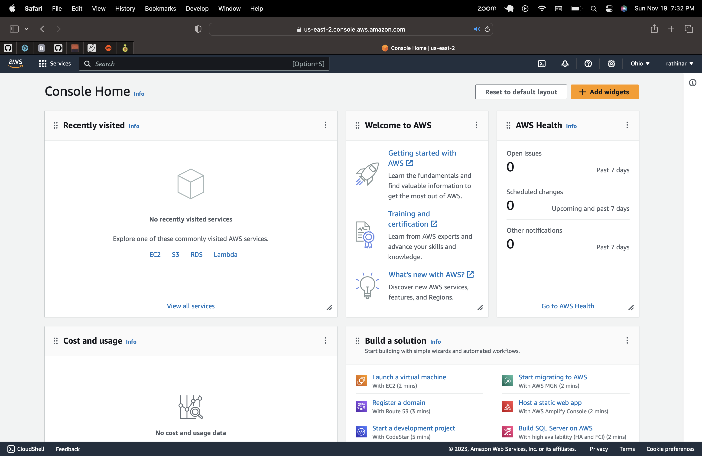

**IAM user setup for team -**

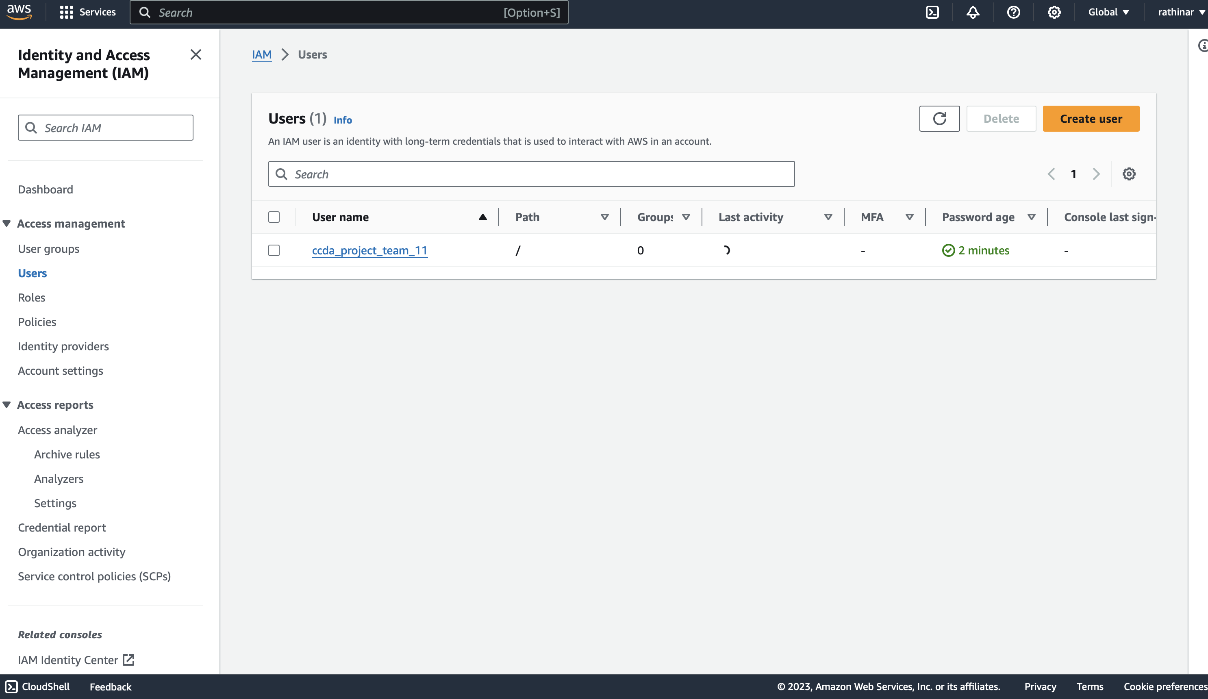

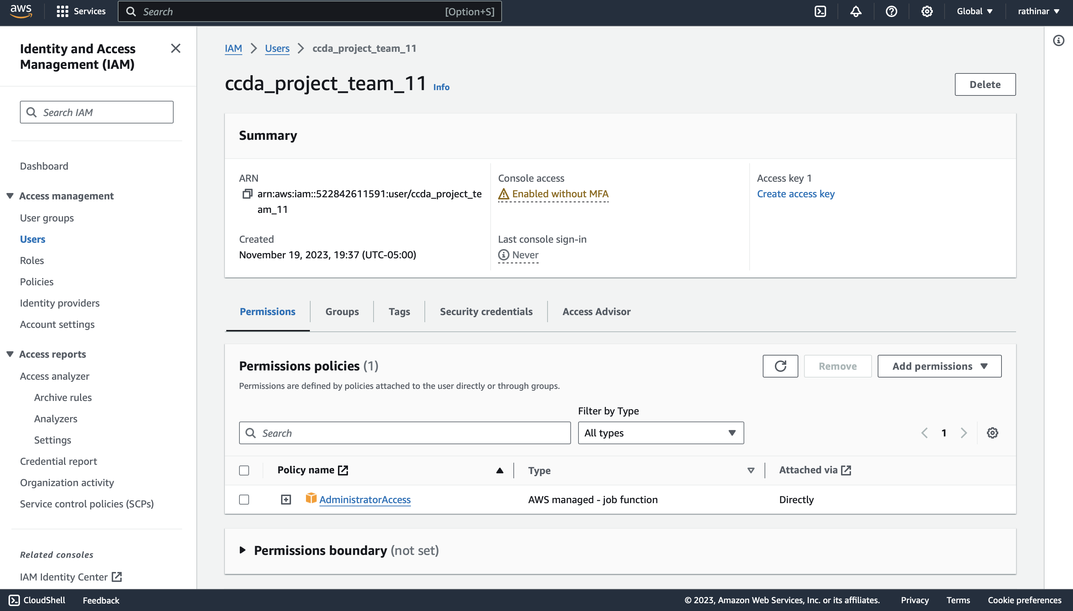

**Logged into user – ccda_project_team_11**

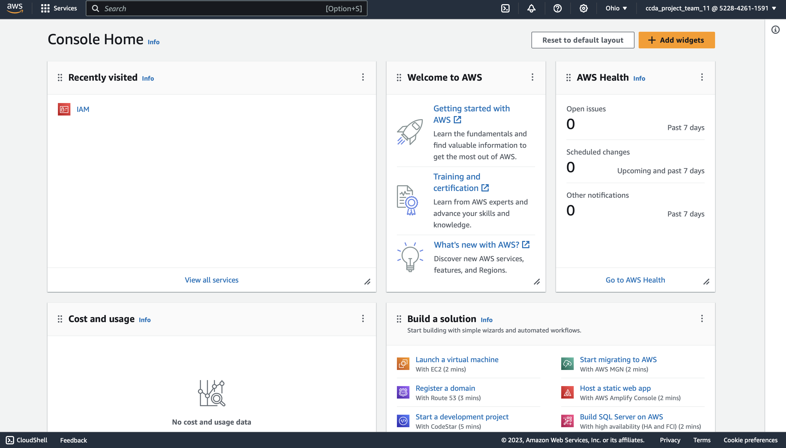

**DATASET –**

For dataset, we are using Google’s open images dataset, setting the type to detection and based on our scope of the project, we are searching for prelabeled plastic bag images.

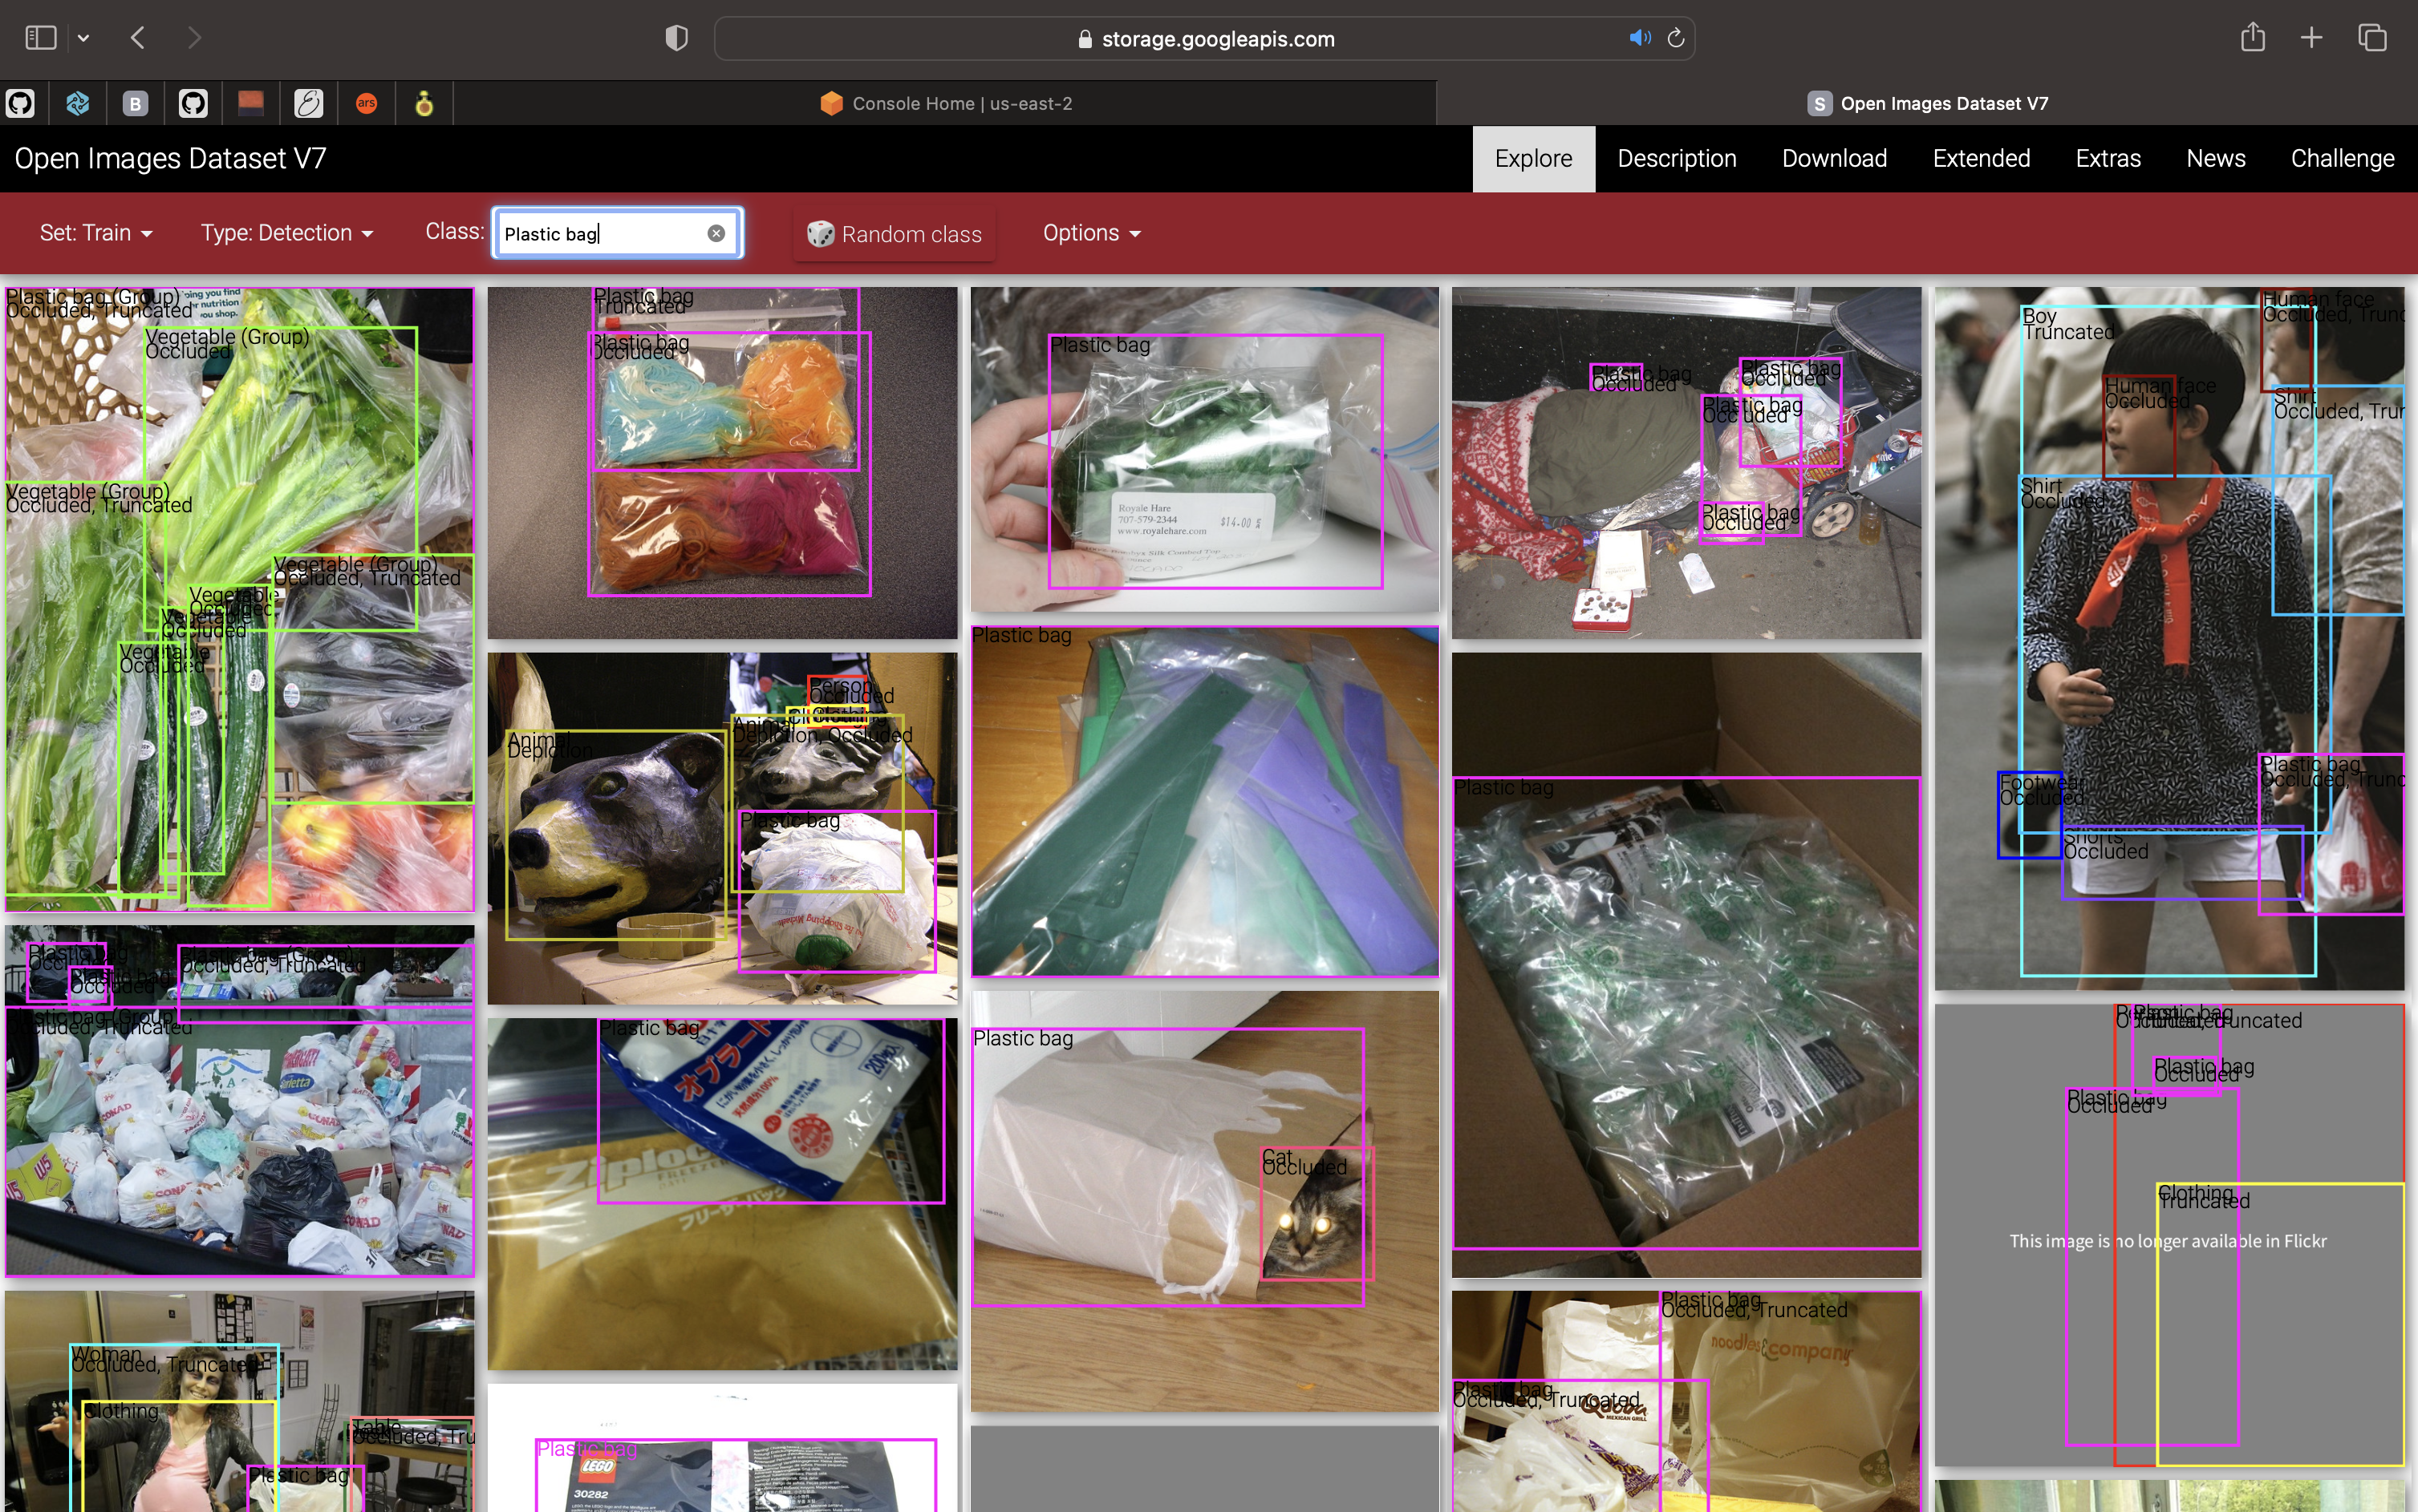

We have utilized fiftyone to download the dataset –

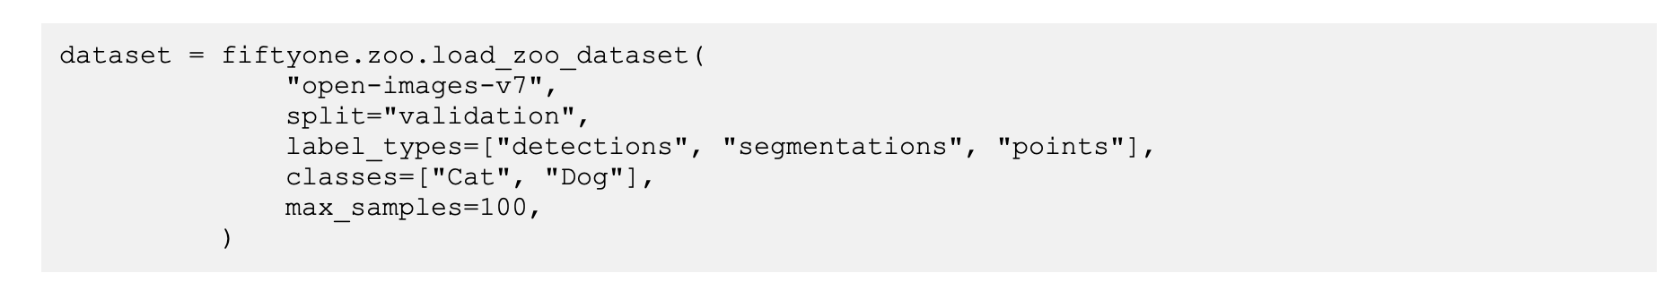

Python code –

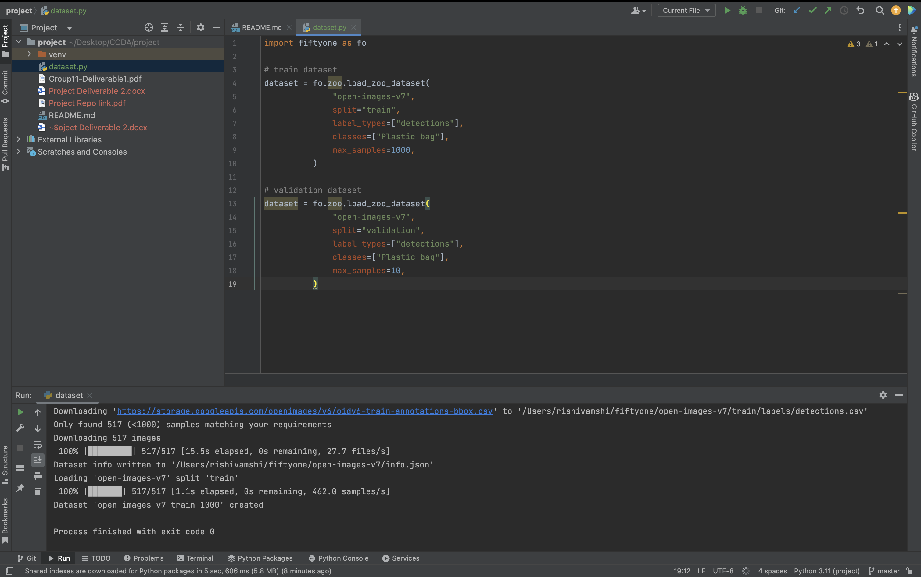

Dataset downloaded –

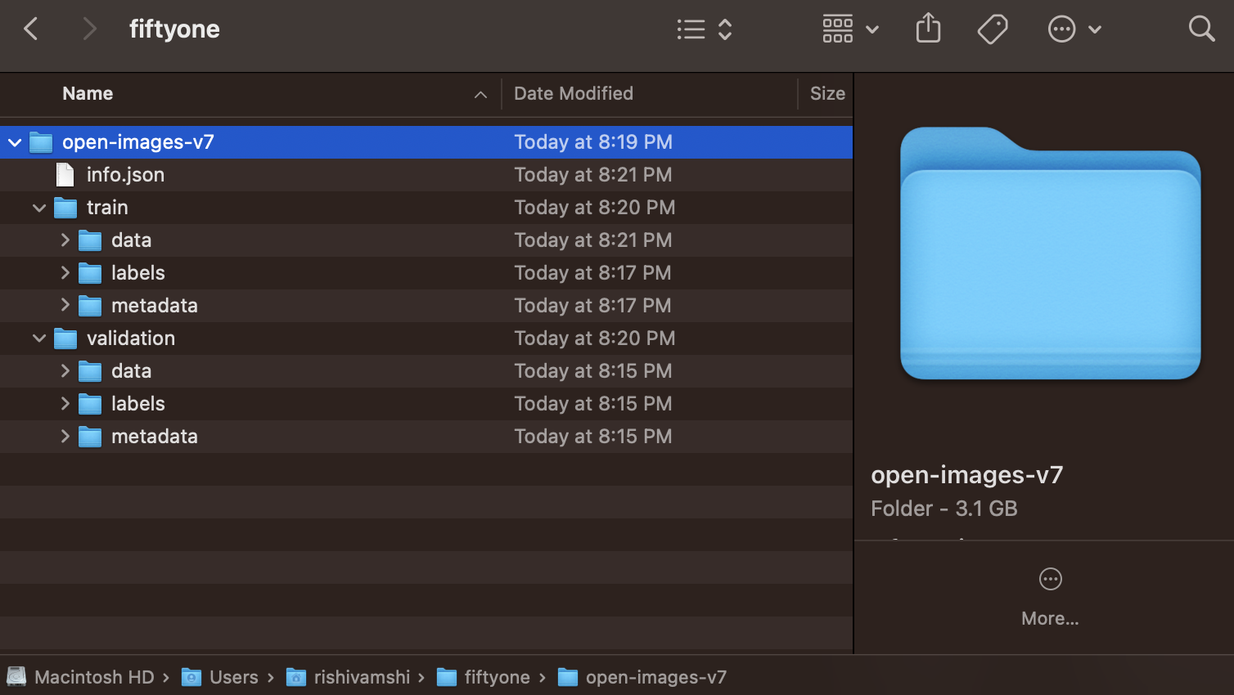

Sagemaker –

Created domain for the project and user –

